**Temporary SEND Arrangements**

I am writing to inform you that Mr Pollock, our SENCO, is currently off sick. While we hope for his swift recovery, we want to ensure that the support for our SEND students and families continues smoothly during his absence. To that end, we have temporarily restructured responsibilities among our team. This plan will help us maintain consistency and provide the best possible support for your child.

**Key Roles**

Mr French will be acting as Inclusion Lead and will oversee both SSC and Cabin, including:

* SEND teaching assistant (TA) support and scheduling
* Interventions and specialist programmes
* Placement consultations
* Annual reviews
* SEND referral process and screening

Mrs Mayhead will take on the role of Acting SENCO and will:

* Coordinate operational running of Teaching Assistants

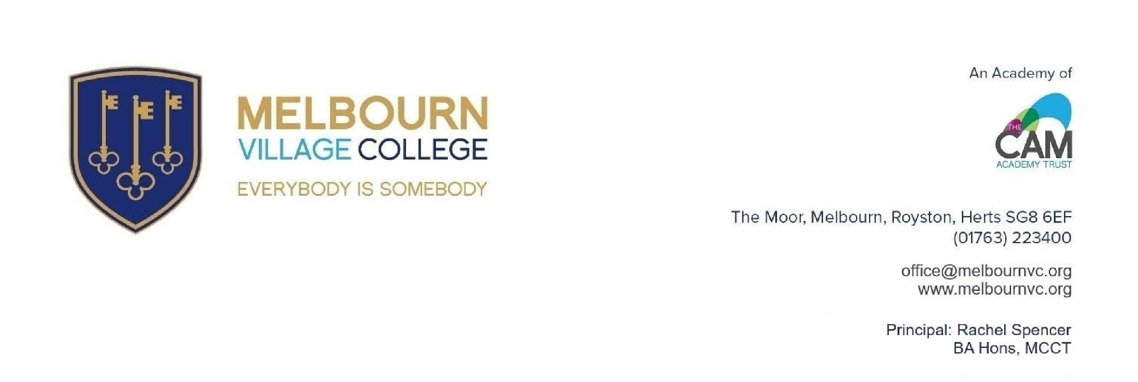

Friday 23

rd

May 2025

Dear Parents and Carers,

* Quality assurance of interventions
* Continue with annual reviews for the students she already works with

We have also secured further support from Mrs Neagle, our Director of SEND within the Trust who will be on site each week after half term.

Please note, **there will be no change for students within our Cabin provision**. The current support and structure in place will continue as normal. Should you have any queries, please do not hesitate to contact our team at SEND@melbournvc.org.

We hope this temporary plan provides reassurance. Our commitment to supporting your child’s needs remains our top priority, and we’ll keep you informed of any further updates. Thank you, as always, for your support.

Kind regards

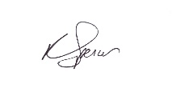

Mrs Spencer

Principal